|  |  |
| --- | --- |
| Universidad Galileo  Diseño y Construcción de Data Warehouses  Catedrático: Luis Fernando Leal | Eduardo Santizo Olivet  Carné: 21007361  Sección: U |

**Tarea No. 4**

Tarea Preparatoria para el Parcial

Usuario: <https://www.hackerrank.com/eddysanoli>

**Problema 1**: If else

Link: <https://www.hackerrank.com/challenges/py-if-else/problem>

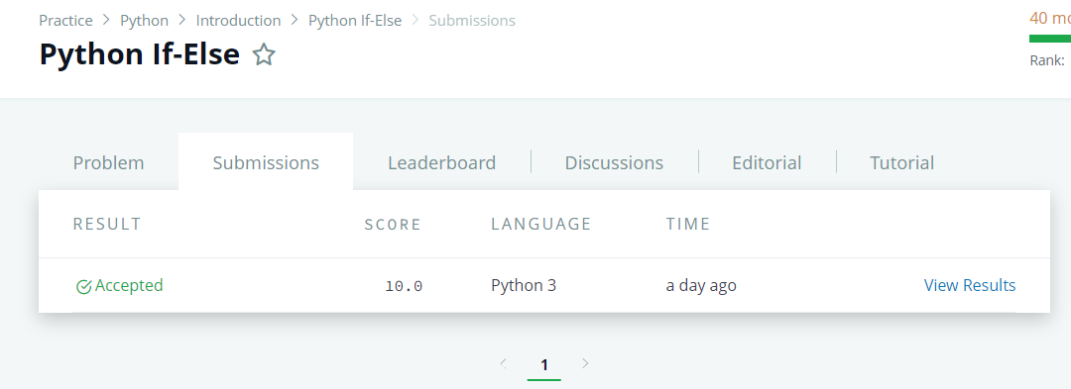

**Problema 2**: Operadores aritméticos

Link: <https://www.hackerrank.com/challenges/python-arithmetic-operators/problem>

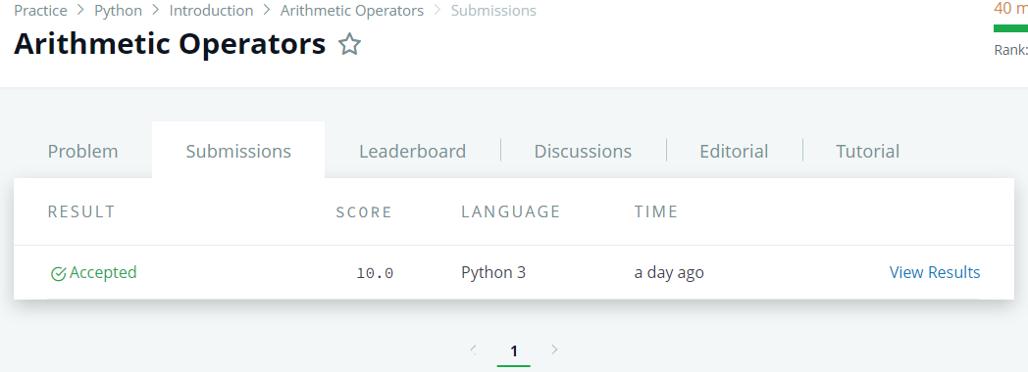

**Problema 3**: División

Link: <https://www.hackerrank.com/challenges/python-division/problem>

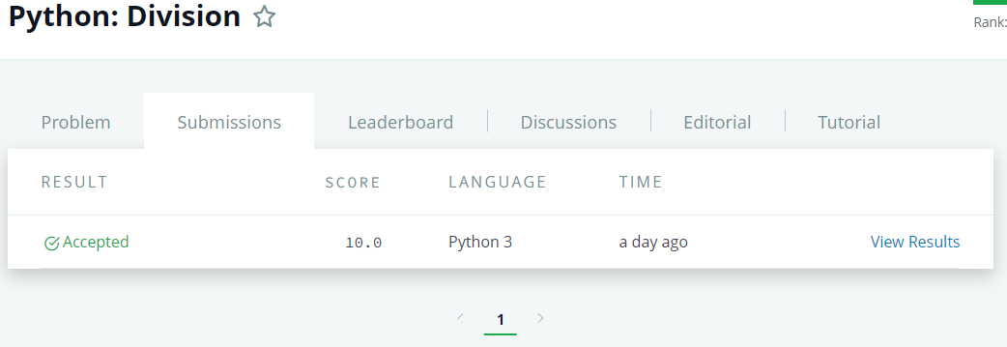

**Problema 4**: Loops

Link: <https://www.hackerrank.com/challenges/python-loops/problem>

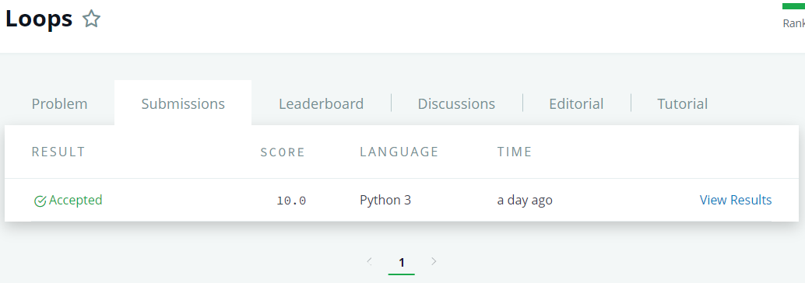

**Problema 5**: Funciones

Link: <https://www.hackerrank.com/challenges/write-a-function/problem>

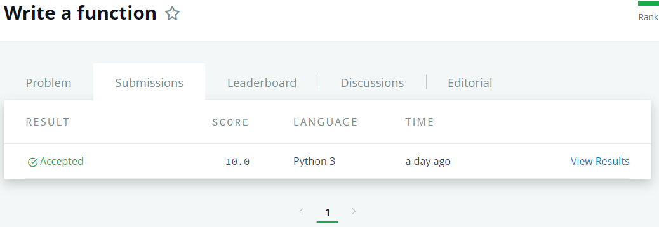

**Problema 6**: Segundo Número más Alto

Link: <https://www.hackerrank.com/challenges/find-second-maximum-number-in-a-list/problem>

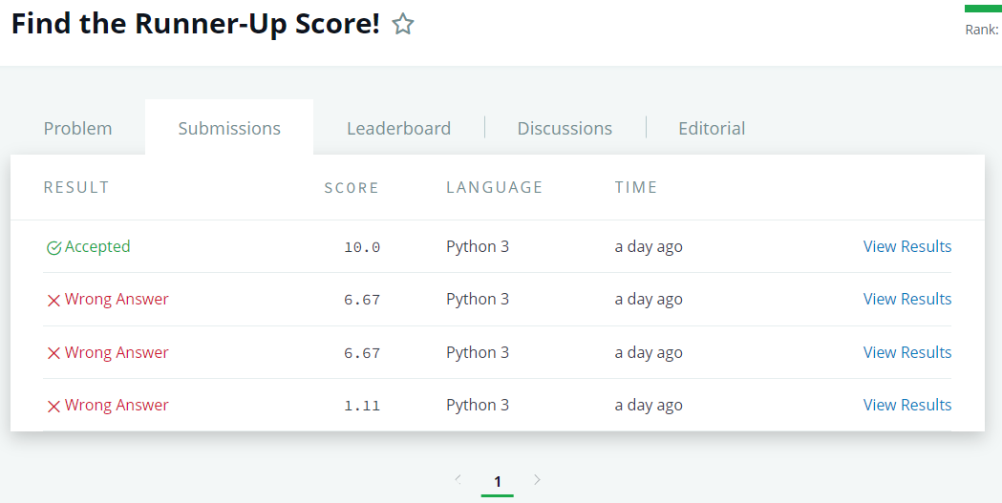

**Problema 7**: Porcentaje

Link: <https://www.hackerrank.com/challenges/finding-the-percentage/problem>

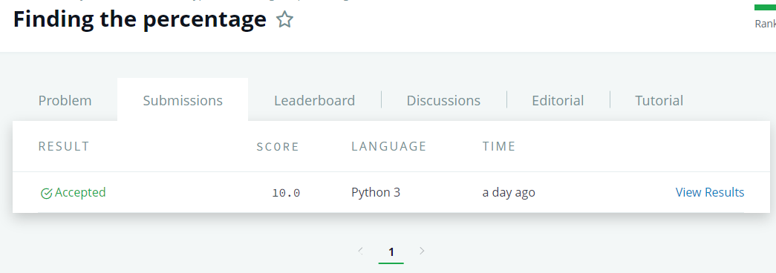

**Problema 8**: Listas

Link: <https://www.hackerrank.com/challenges/python-lists/problem>



**Problema 9**: Tuplas

Link: <https://www.hackerrank.com/challenges/python-tuples/problem>



**Problema 10**: DefaultDict

Link: <https://www.hackerrank.com/challenges/defaultdict-tutorial/problem>

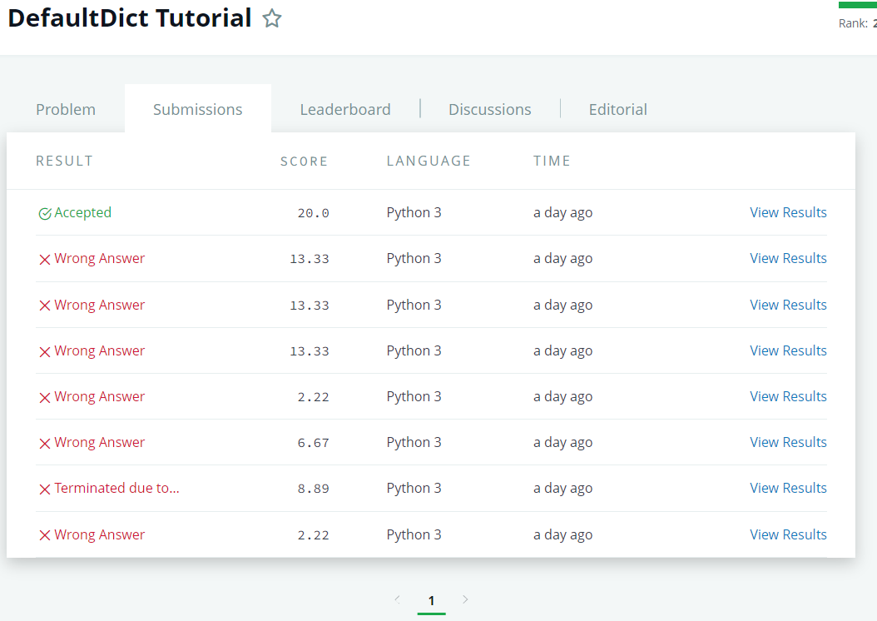

**Problema 11**: Counter

Link: <https://www.hackerrank.com/challenges/collections-counter/problem>

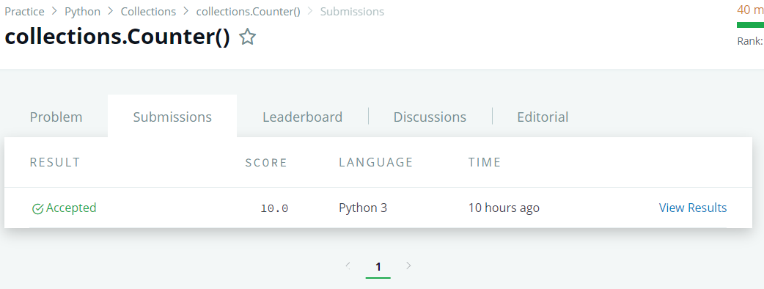

**Problema 12**: Swaps Mínimos

Link: <https://www.hackerrank.com/challenges/minimum-swaps-2/problem?h_l=interview&playlist_slugs%5B%5D=interview-preparation-kit&playlist_slugs%5B%5D=arrays>

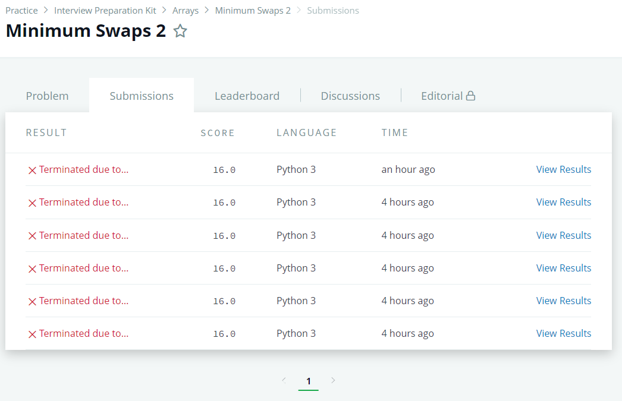

**Problema 13**: Floor, Ceil y Rint

Link: <https://www.hackerrank.com/challenges/floor-ceil-and-rint/problem>

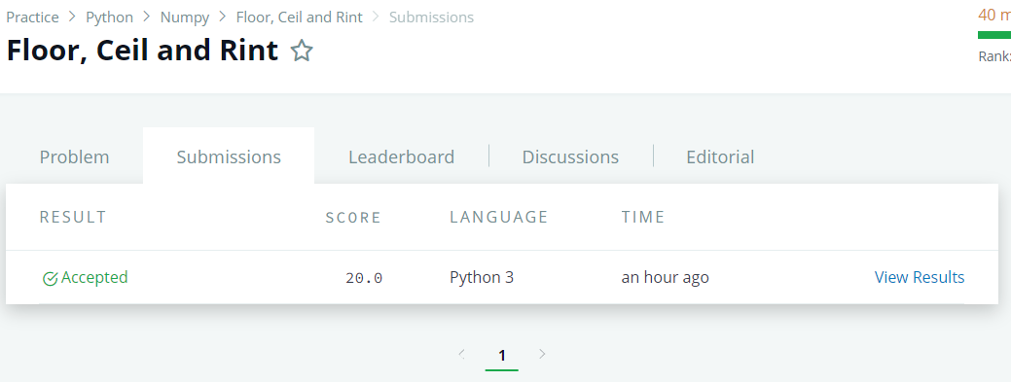

**Problema 14**: Bubble Sort

Link: <https://www.hackerrank.com/challenges/ctci-bubble-sort/problem?h_l=interview&playlist_slugs%5B%5D=interview-preparation-kit&playlist_slugs%5B%5D=sorting> 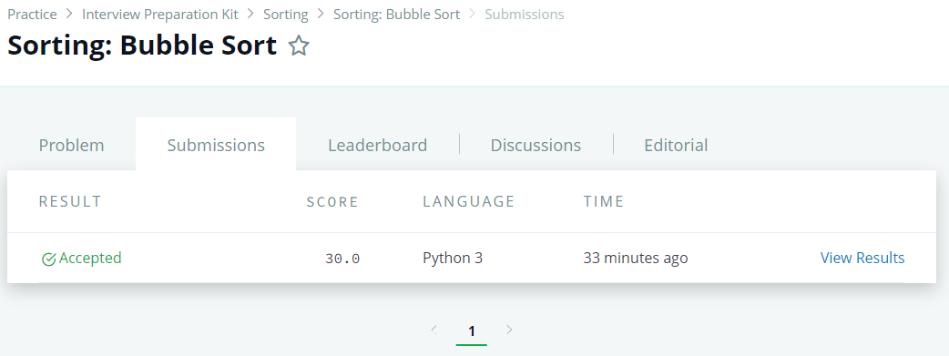

**Problema 15**: Numpy Arrays

Link: <https://www.hackerrank.com/challenges/np-arrays/problem>

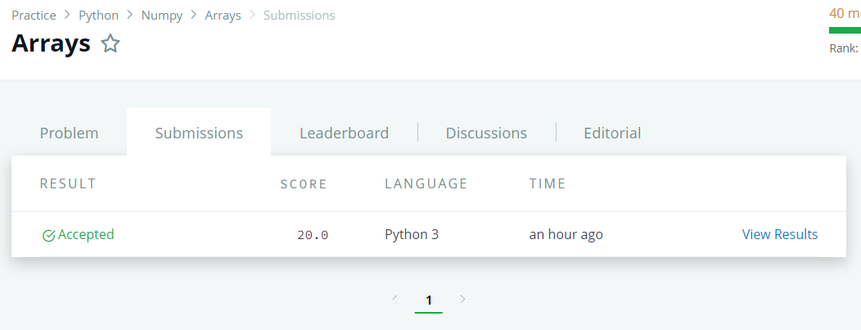

**Problema 16:** Zeros y Ones

Link: <https://www.hackerrank.com/challenges/np-zeros-and-ones/problem>

